Brian Davis

tug75084

915409443

25 March 2020

Project 1: Image Processing Lab

This Image Processing Application is composed of a web tier, application tier, and storage tier. The web tier takes an image from the user, allows the user to select an image filter, and displays the processed image to the user. The application tier handles the processing of the image. The storage tier stores the processed images in a reliable and secure fashion. The server is built using the Django framework, a powerful tool for crafting functional websites. The steps below demonstrate how to set up this project and document my implementation:

The first step to ensuring that this server works properly is creating an EC2 instance with the proper Security Groups in order to handle clients accessing the domain. This can be seen in the image below, where the EC2 instance was launched with 2 additional TCP ports, 8000 and 8080, which can be used to handle incoming requests to the server.

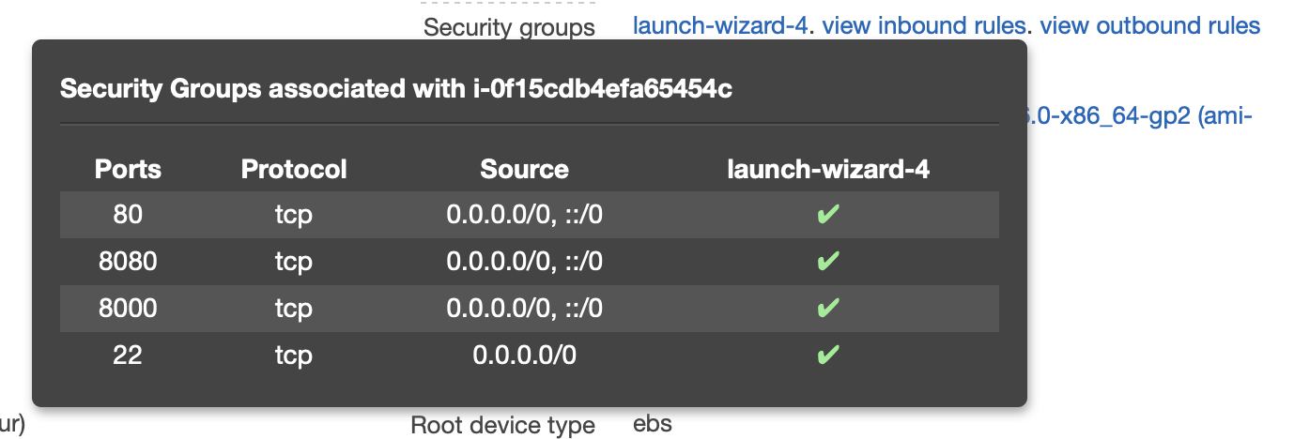

After creating the EC2 instance, create a new S3 bucket as seen below. This bucket will be used for storage persistence of the processed images:

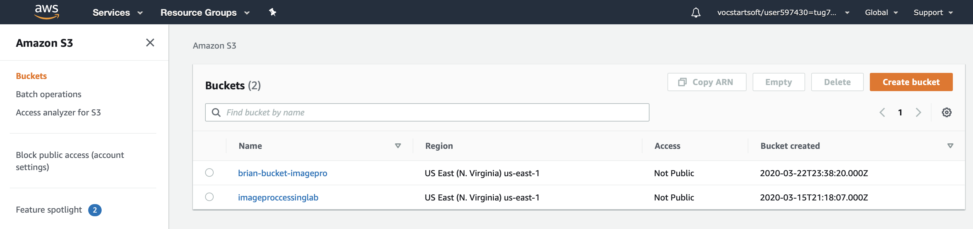

Next, use the Identity and Access Management entity, known as IAM role, in order to interface the new EC2 instance with the S3 bucket:

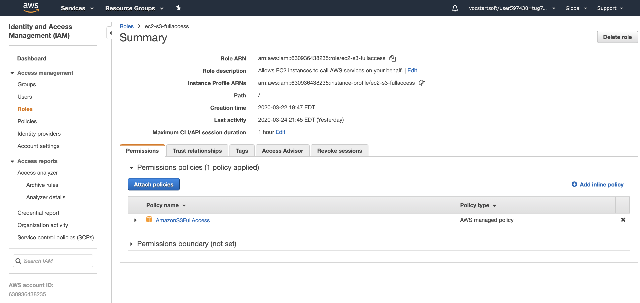

Now, launch the EC2 instance and connect to it via SSH. Keep the Public DNS handy for the Web Application.

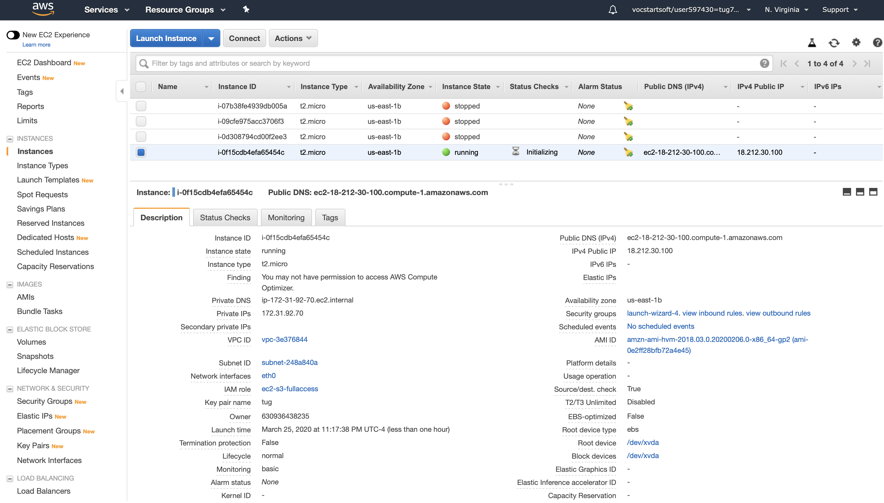

Connect to the EC2 instance via SSH and run the server with TCP port 8080:

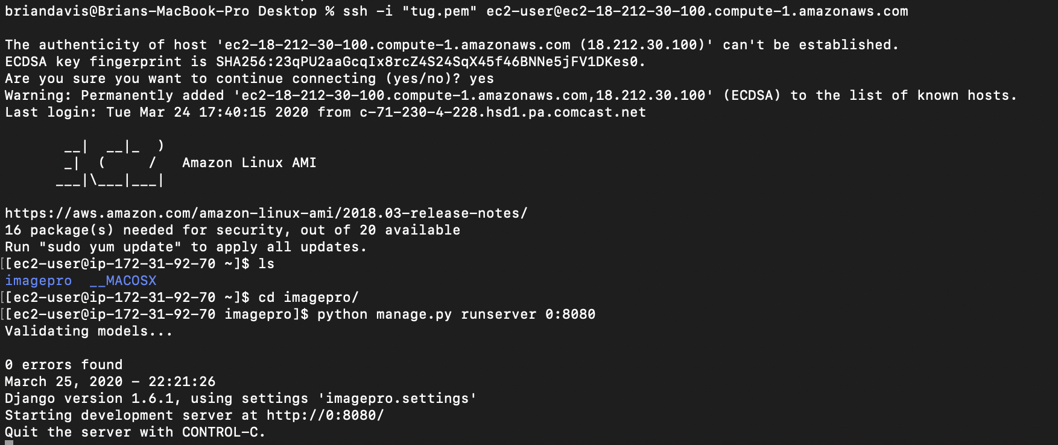

State of the Image Processing Application during launch:

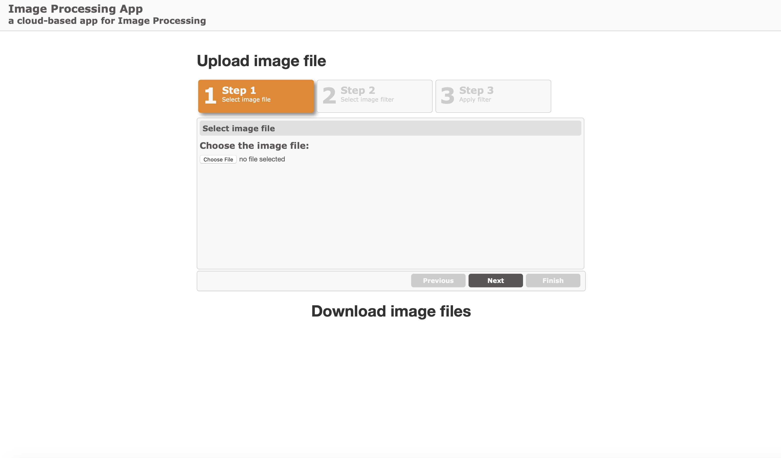

After an image is selected and a filter is selected, the filtered image is displayed. The user has the option to download the image immediately by clicking the blue download button:

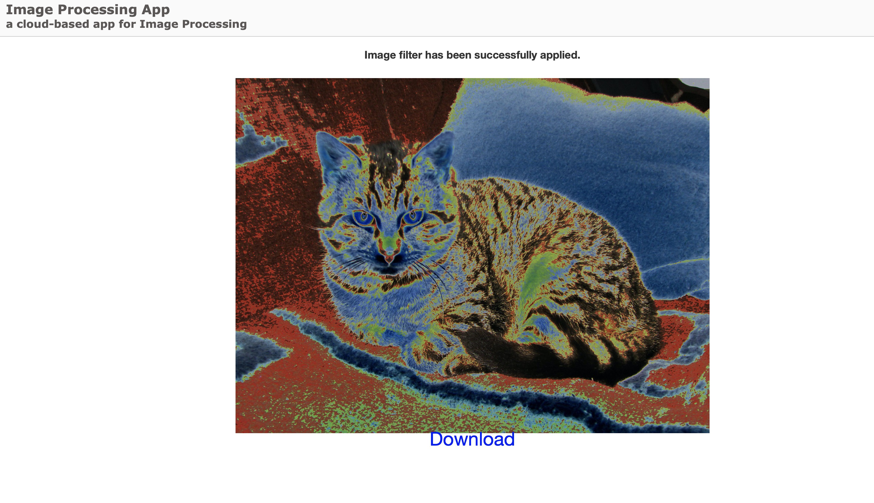

The filtered image is now stored in S3 storage as a means of storage persistence:

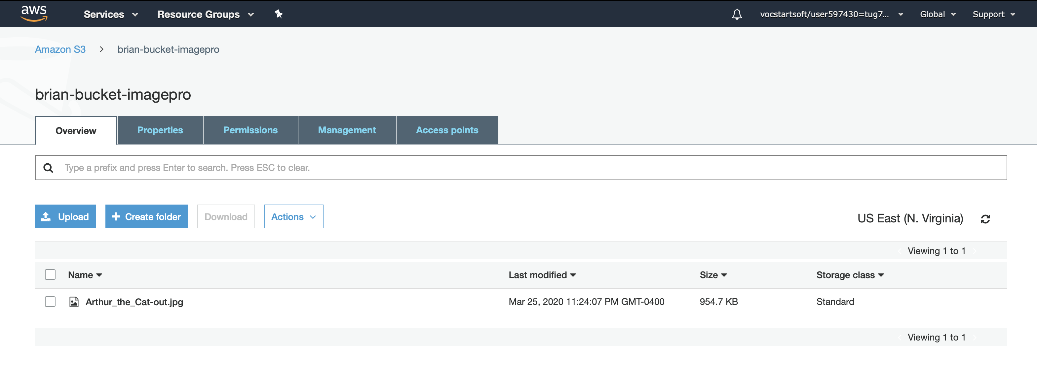

When the webpage is reloaded, the filtered images that are in S3 storage will be displayed and available to download via the blue download button. This Download Portal displays all of the filtered images from S3. The user can either download some of the previously filtered images or filter another image.

